Day 8

**Day 8**

Create table facility. Add the below fields into it.

* Facility_ID
* Name
* State
* Country

i) Alter the table by adding the primary key and auto increment to Facility_ID column.

ii) Add a new column city after name with data type as varchar which should not accept any null values.

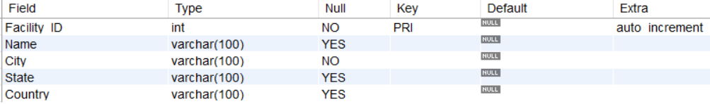

Ans)

